**IT313 Software Engineering**



**Software Engineering Project Group 27 - SkyLynx**

**GUI Testing**

**List of Webpages.**

1. Home Page
2. Login Page
3. Sign up Page
4. Flights Page
5. Booking Page
6. About Us – Our Team Page
7. Add Ons Page
8. Payment Page
9. Profile Page
10. FAQ Page

# Home Page:

|  |  |  |
| --- | --- | --- |
| **Functionality** | **Comments** | **Errors to be**  **resolved** |
| Text | Done, all text aligned | None |
| Text-fields | Done, all text fields working | None |
| Dropdown | Done, Working properly including all necessary options | None |
| Buttons | Done | None |
| Check Box | No Check Box | None |
| Radio Button | Not present | None |
| Hyperlink | Connected to components | None |
| Image | Selection of images done while keeping the theme and context of website in-line. | None |
| Other | User Friendly UI | None |

## Test cases in selenium:

Text-fields:

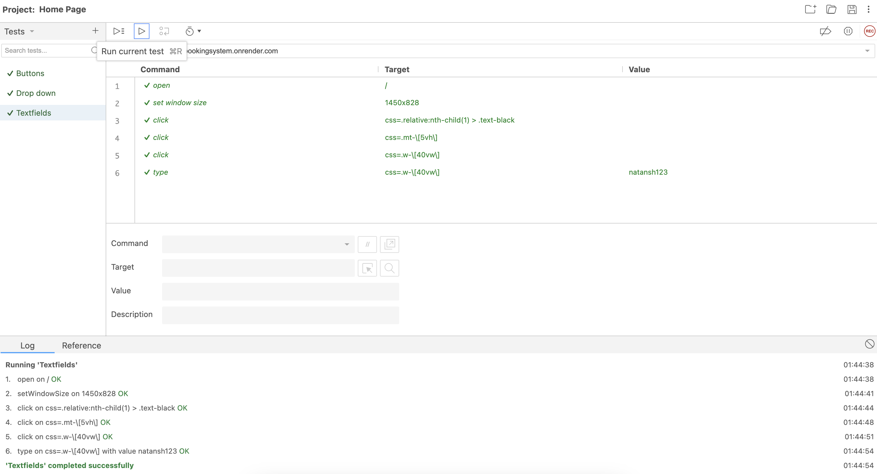

Buttons:

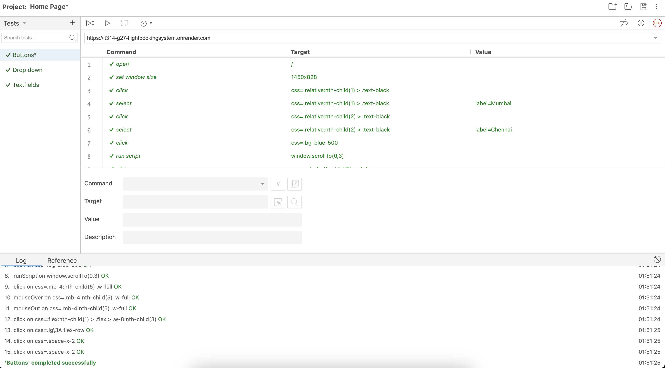

Drop Down :

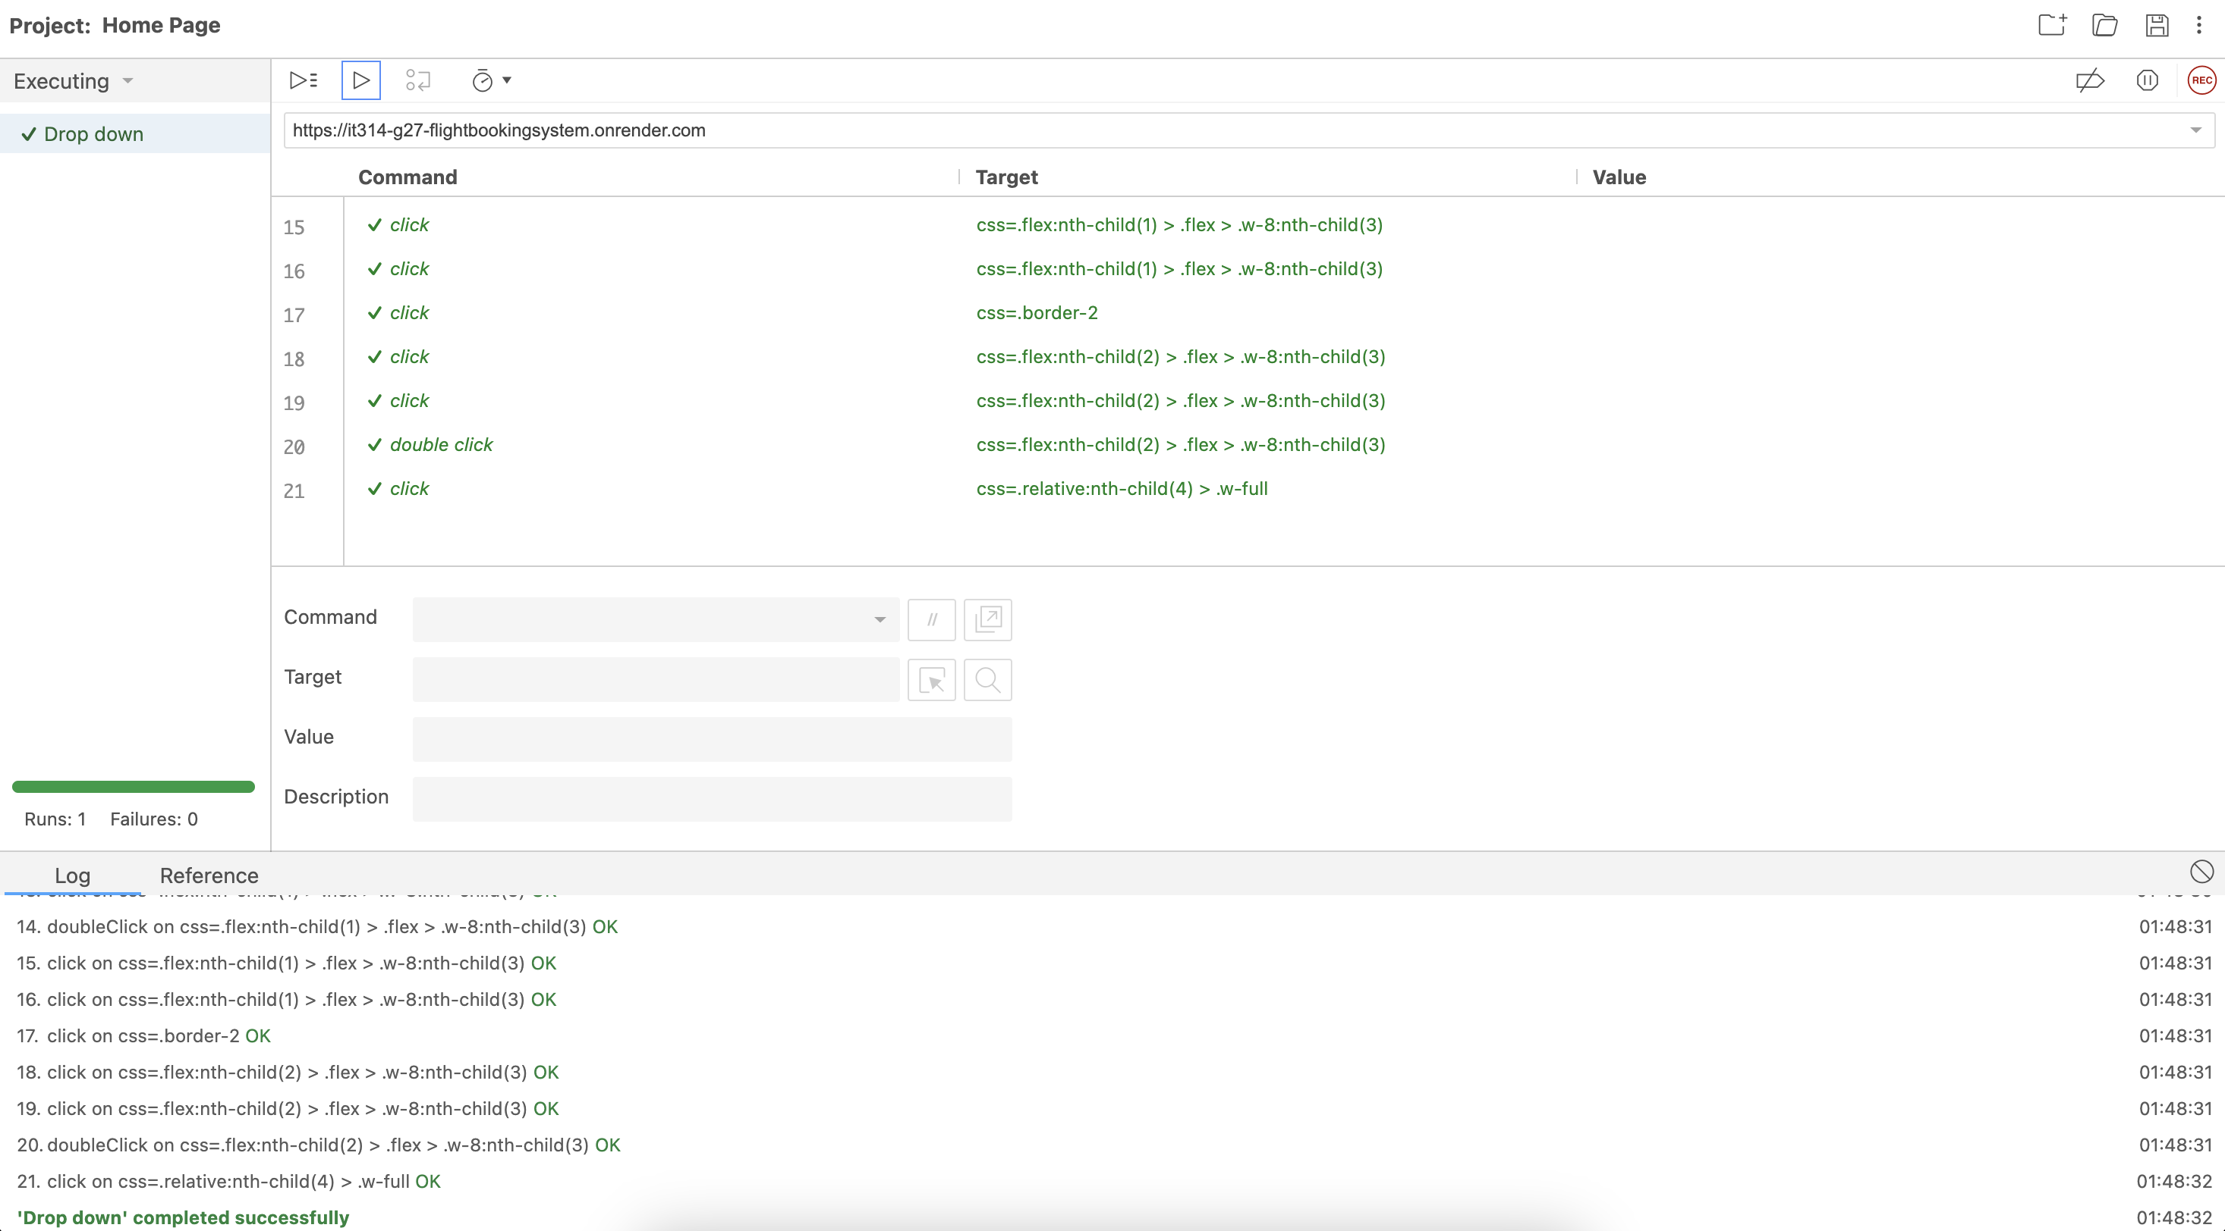

# Log-in Page:

|  |  |  |
| --- | --- | --- |
| **Functionality** | **Comments** | **Errors to be**  **resolved** |
| Text | Done, All text aligned | None |
| Text-fields | Done, all text fields working | None |
| Dropdown | No drop-down | None |
| Buttons | Done, Buttons have a nice style making them easy to read | Image was overlaying on top of button on certain resolutions - fixed |
| Check Box | No Check Box | None |
| Radio Button | Not present | None |
| Hyperlink | Good UI, all links working | None |
| Image | Good selection of images | None |
| Other | Great UI Overall | None |

## Test cases in selenium:

Text-fields:

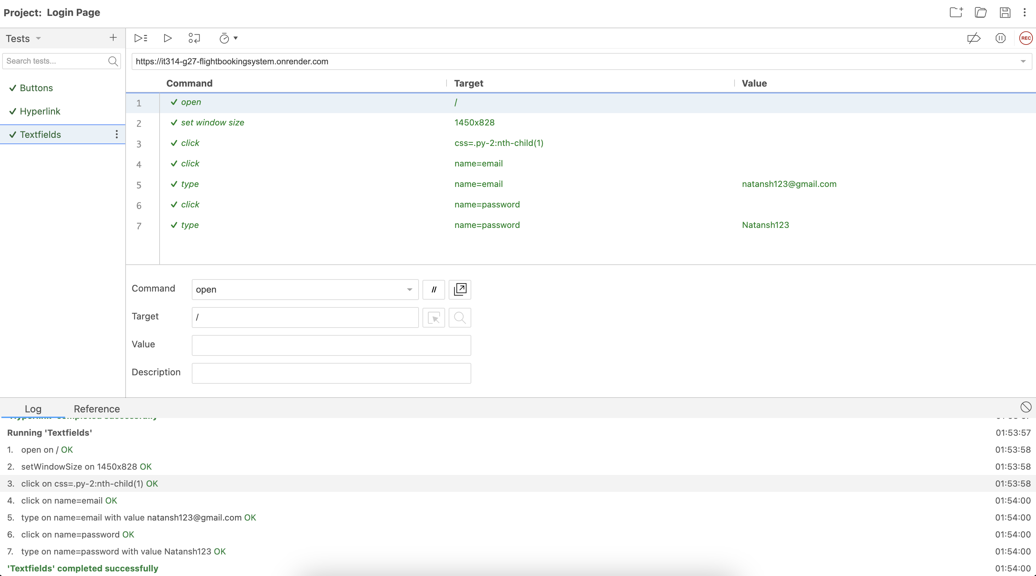

Buttons:

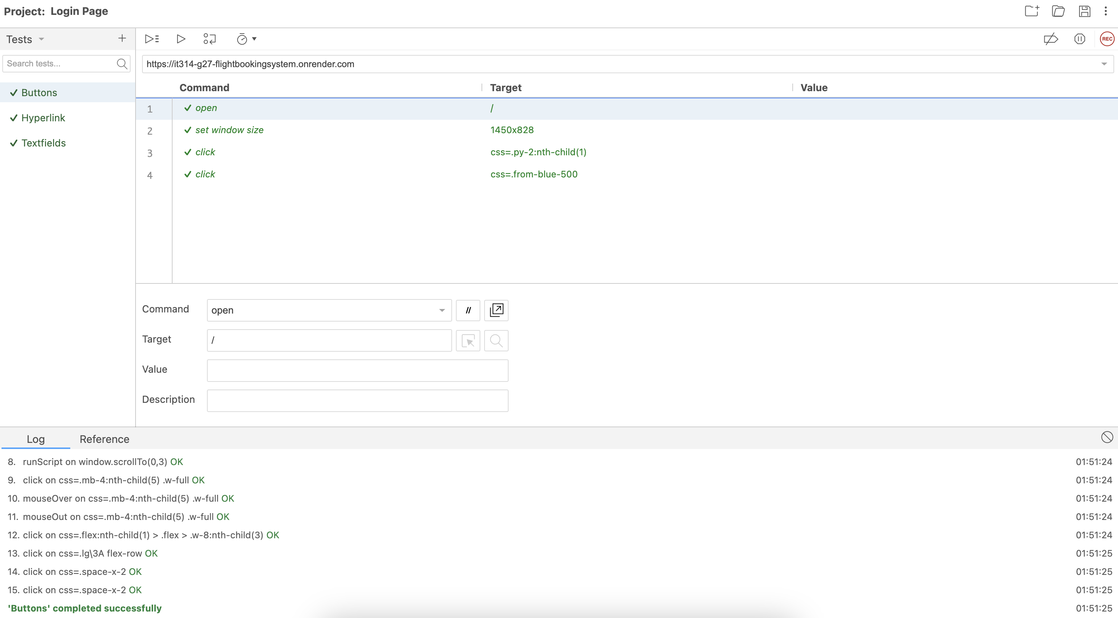

Hyperlink :

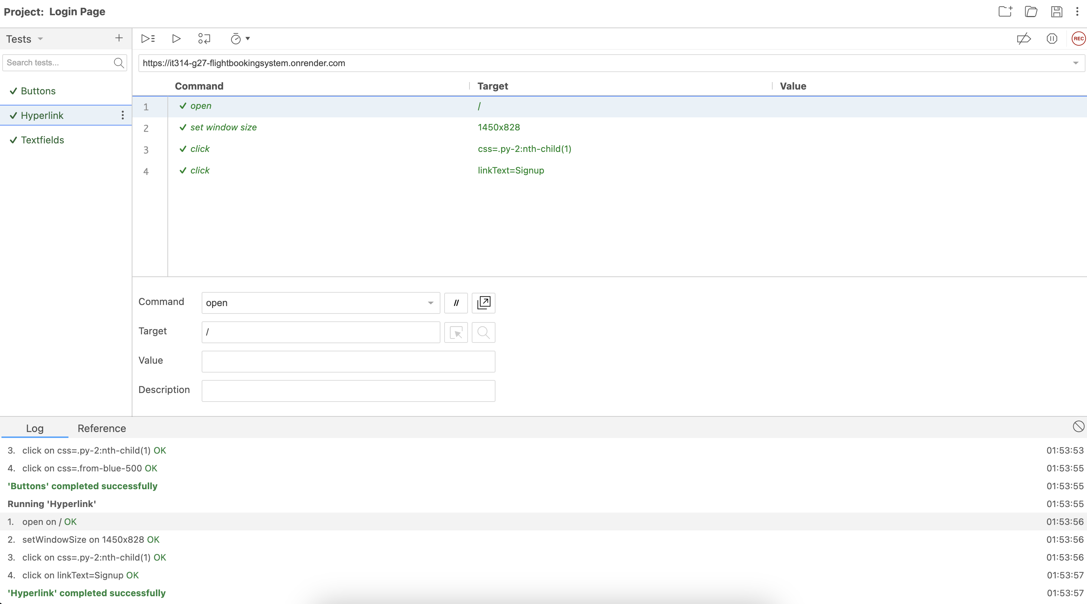

# Sign Up Page:

|  |  |  |
| --- | --- | --- |
| **Functionality** | **Comments** | **Errors to be**  **resolved** |
| Text | Done, All text aligned | None |
| Text-fields | Done, All text-fields working. | None |
| Dropdown | No drop-down | None |
| Buttons | Done, Buttons are working properly. | None |
| Check Box | No Check Box | None |
| Radio Button | Not present | None |
| Hyperlink | All links working perfectly | None |
| Image | Good selection of images | None |
| Other | Great UI Overall | None |

## Selenium Test cases:

Buttons:

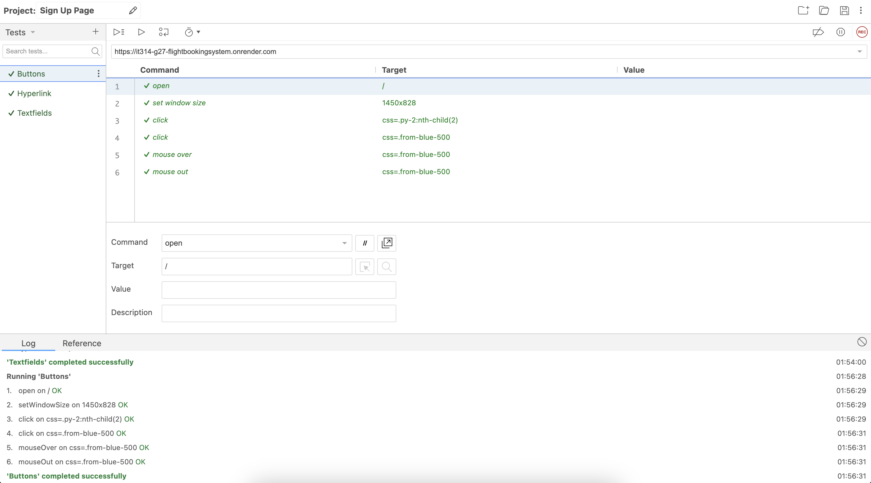

Hyperlink:

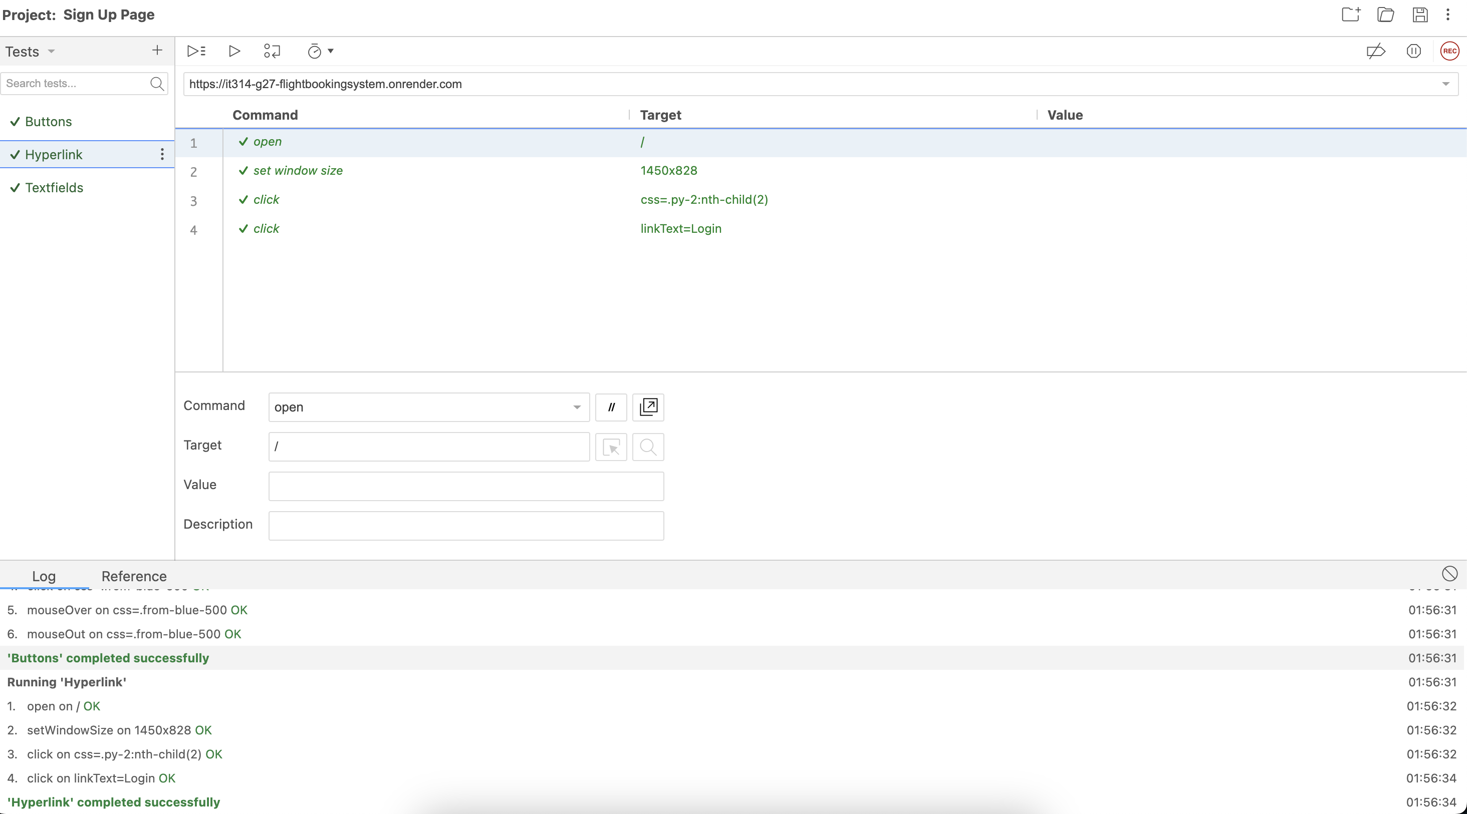

Textfields:

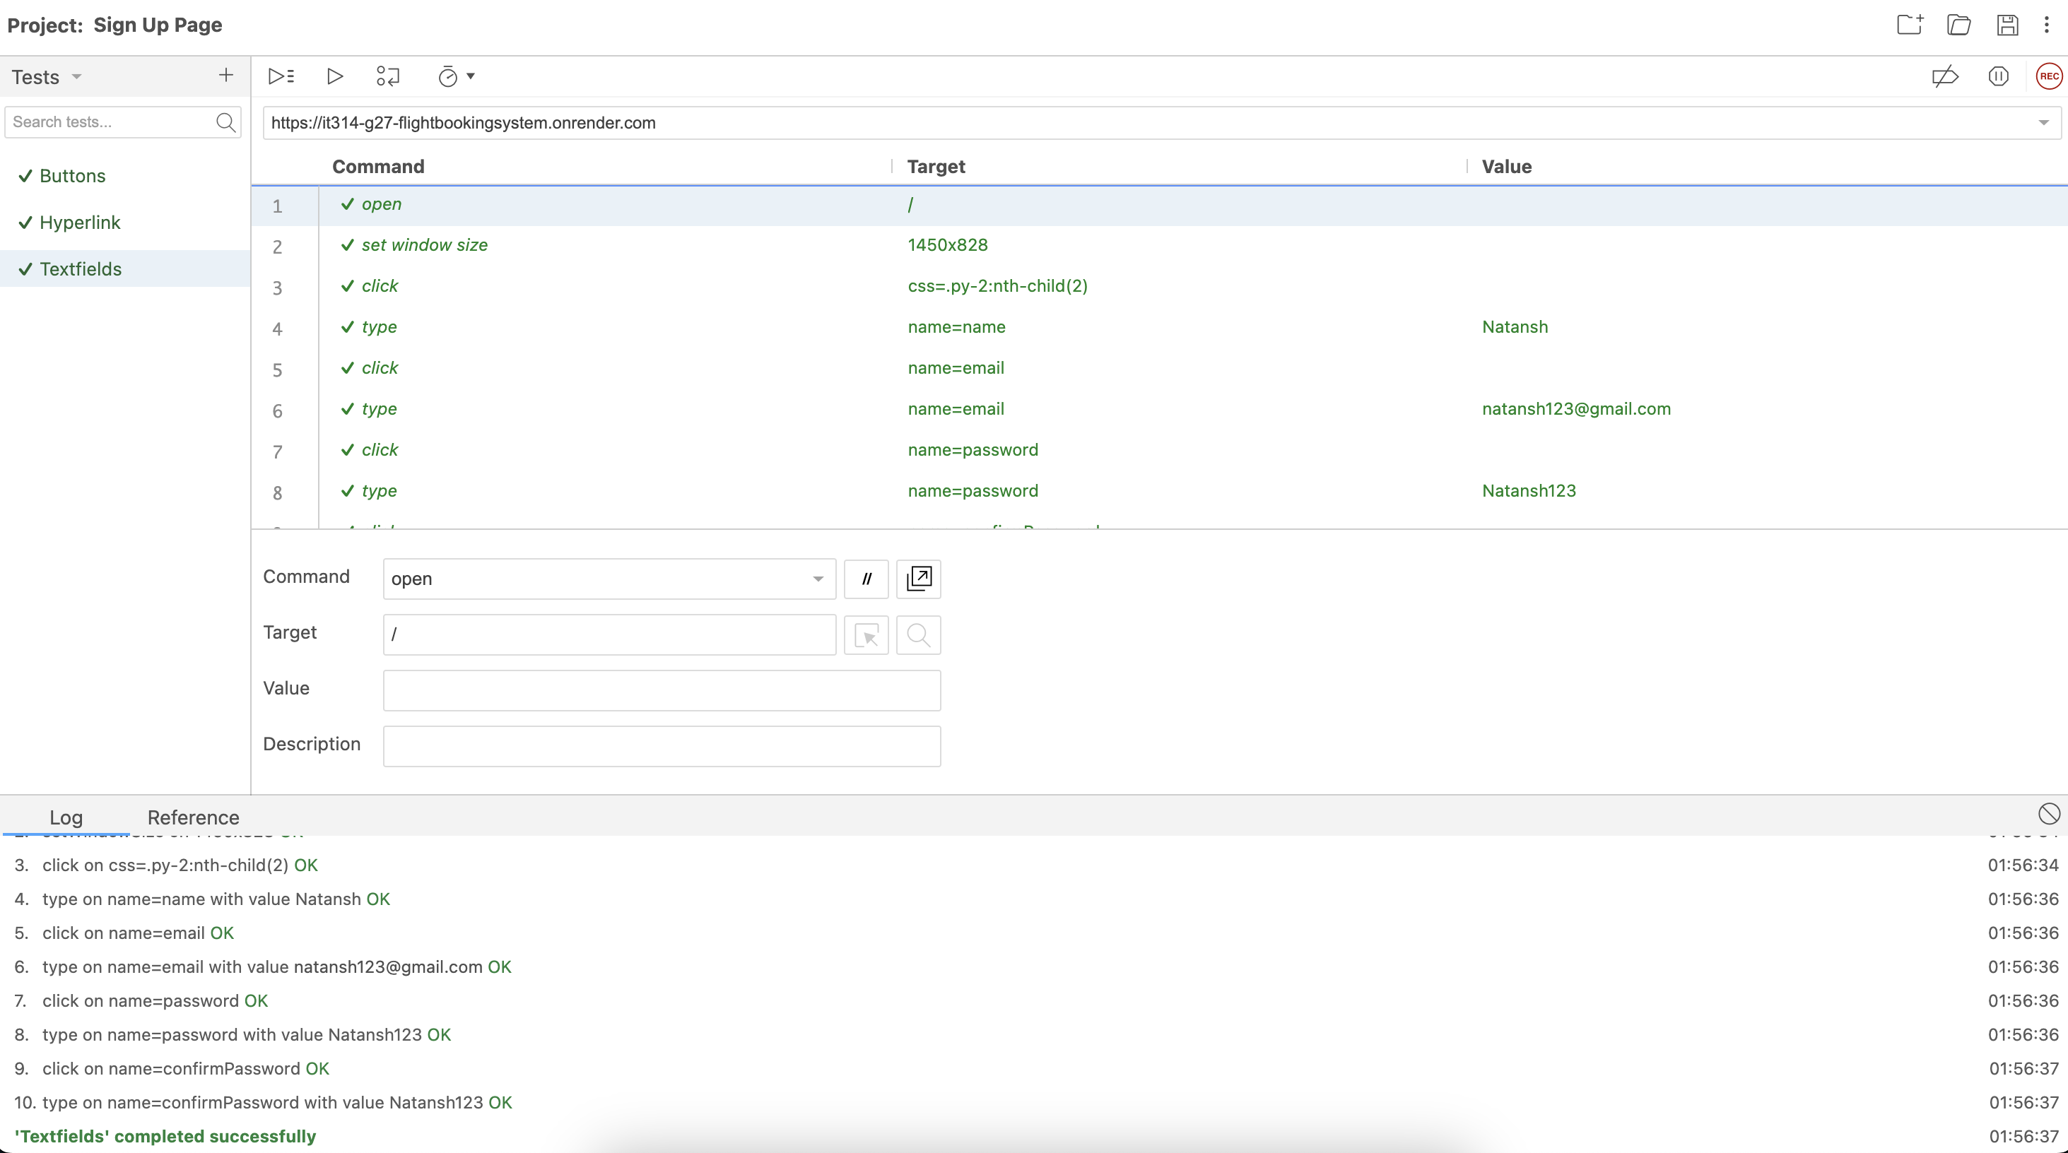

# Flights Page:

|  |  |  |
| --- | --- | --- |
| **Functionality** | **Comments** | **Errors to be**  **resolved** |
| Text | Done, All text aligned | None |
| Text-fields | No text-field present. | None |
| Dropdown | Done, All Dropdowns working perfectly and looking easy to operate because of good UI. | None |
| Buttons | Done, Buttons have a nice style making them easy to read. | None |
| Check Box | No Check Box | None |
| Radio Button | Not present | None |
| Hyperlink | All links working perfectly | None |
| Image | Good selection of images | None |
| Other | Great UI Overall | None |

## Selenium Test cases:

Buttons:

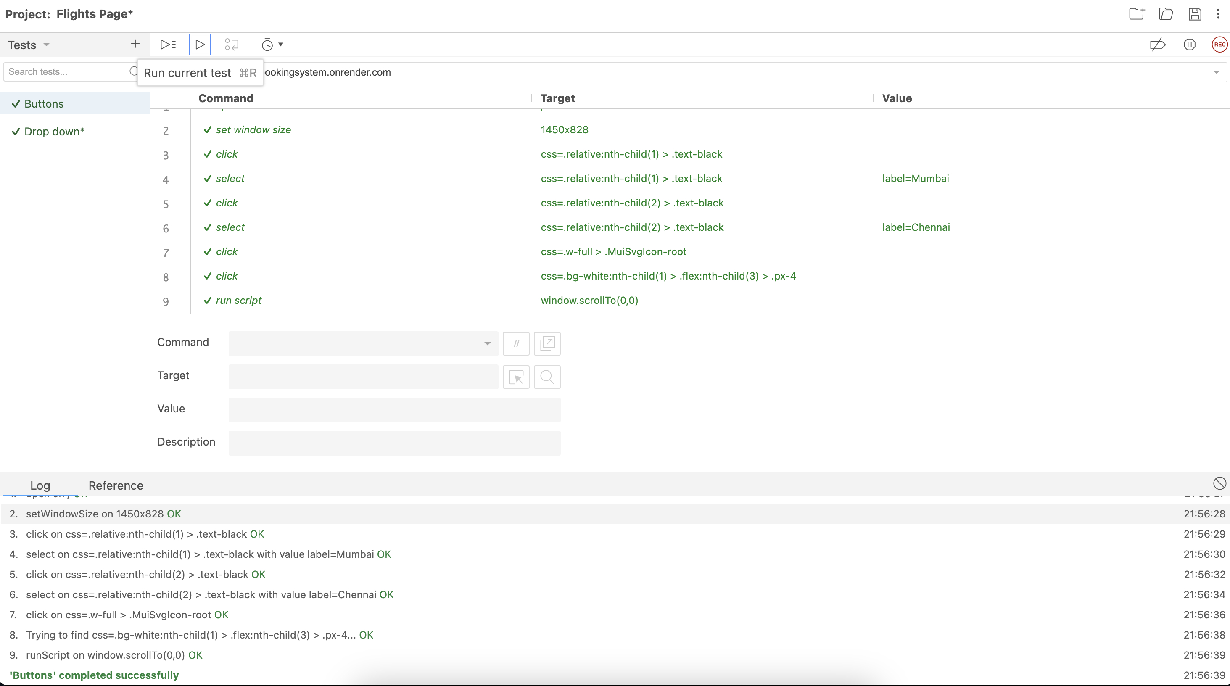

Dropdown:

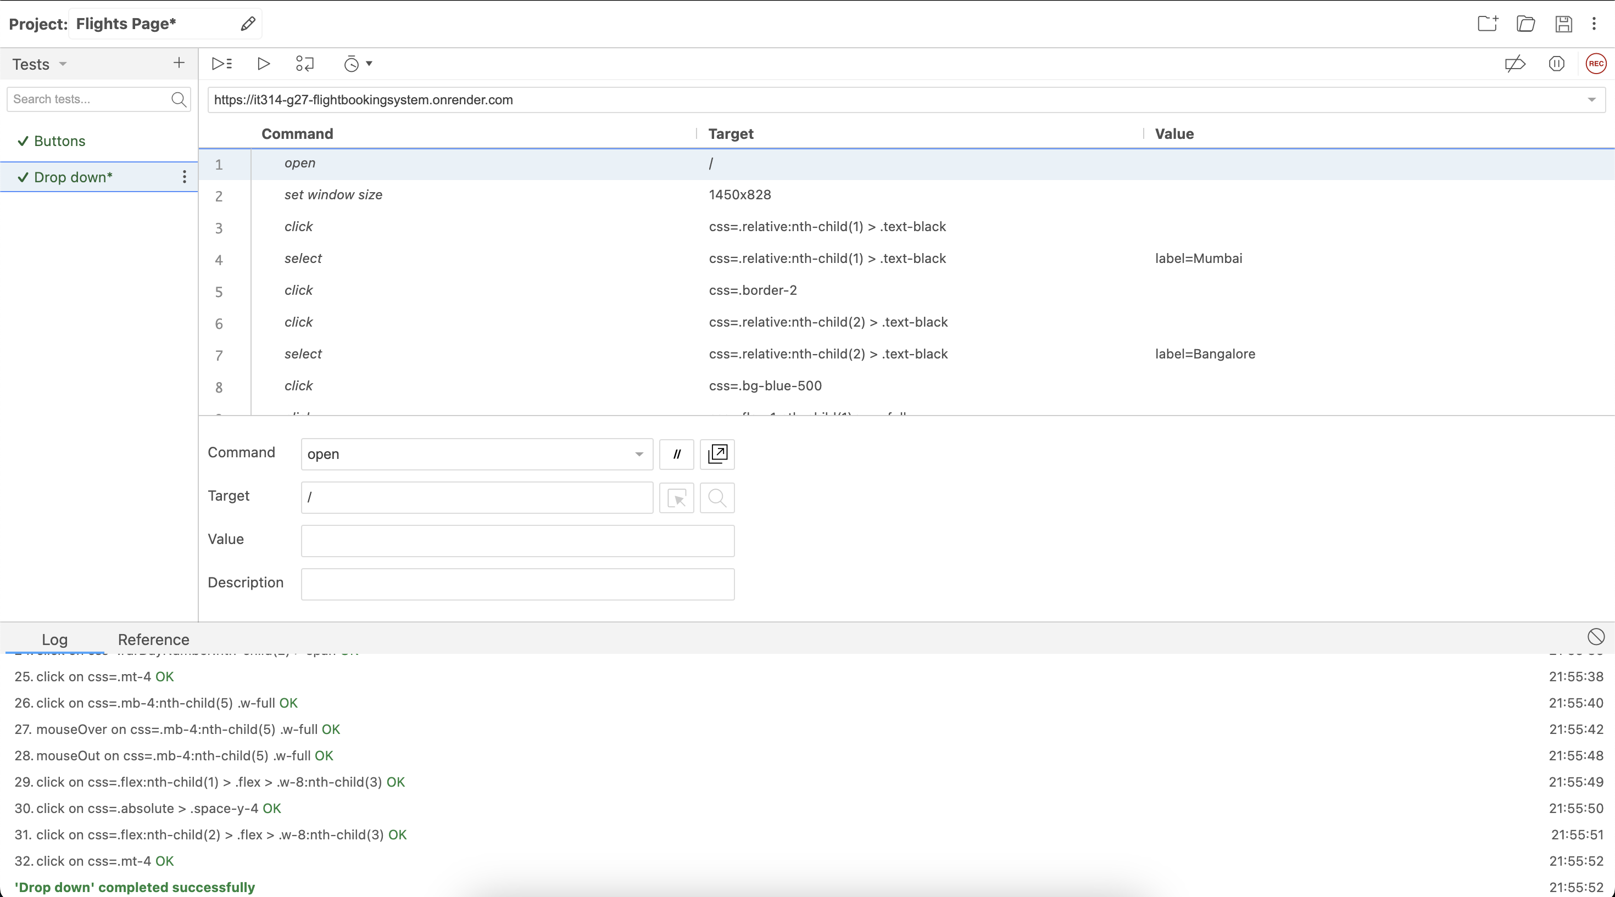

# Booking Page :

|  |  |  |
| --- | --- | --- |
| **Functionality** | **Comments** | **Errors to be**  **resolved** |
| Text | Done, good UI | None |
| Text-fields | Done, All text-fields working properly. | None |
| Dropdown | Done, All Dropdowns working perfectly and looking easy to operate because of good UI. | None |
| Buttons | Done, All buttons working perfectly. | None |
| Check Box | No Check Box | None |
| Radio Button | Not present | None |
| Hyperlink | All links and redirections working perfectly. | None |
| Image | Good selection of images. | None |
| Other | Good UI Overall | None |

## Selenium Test cases:

Buttons :

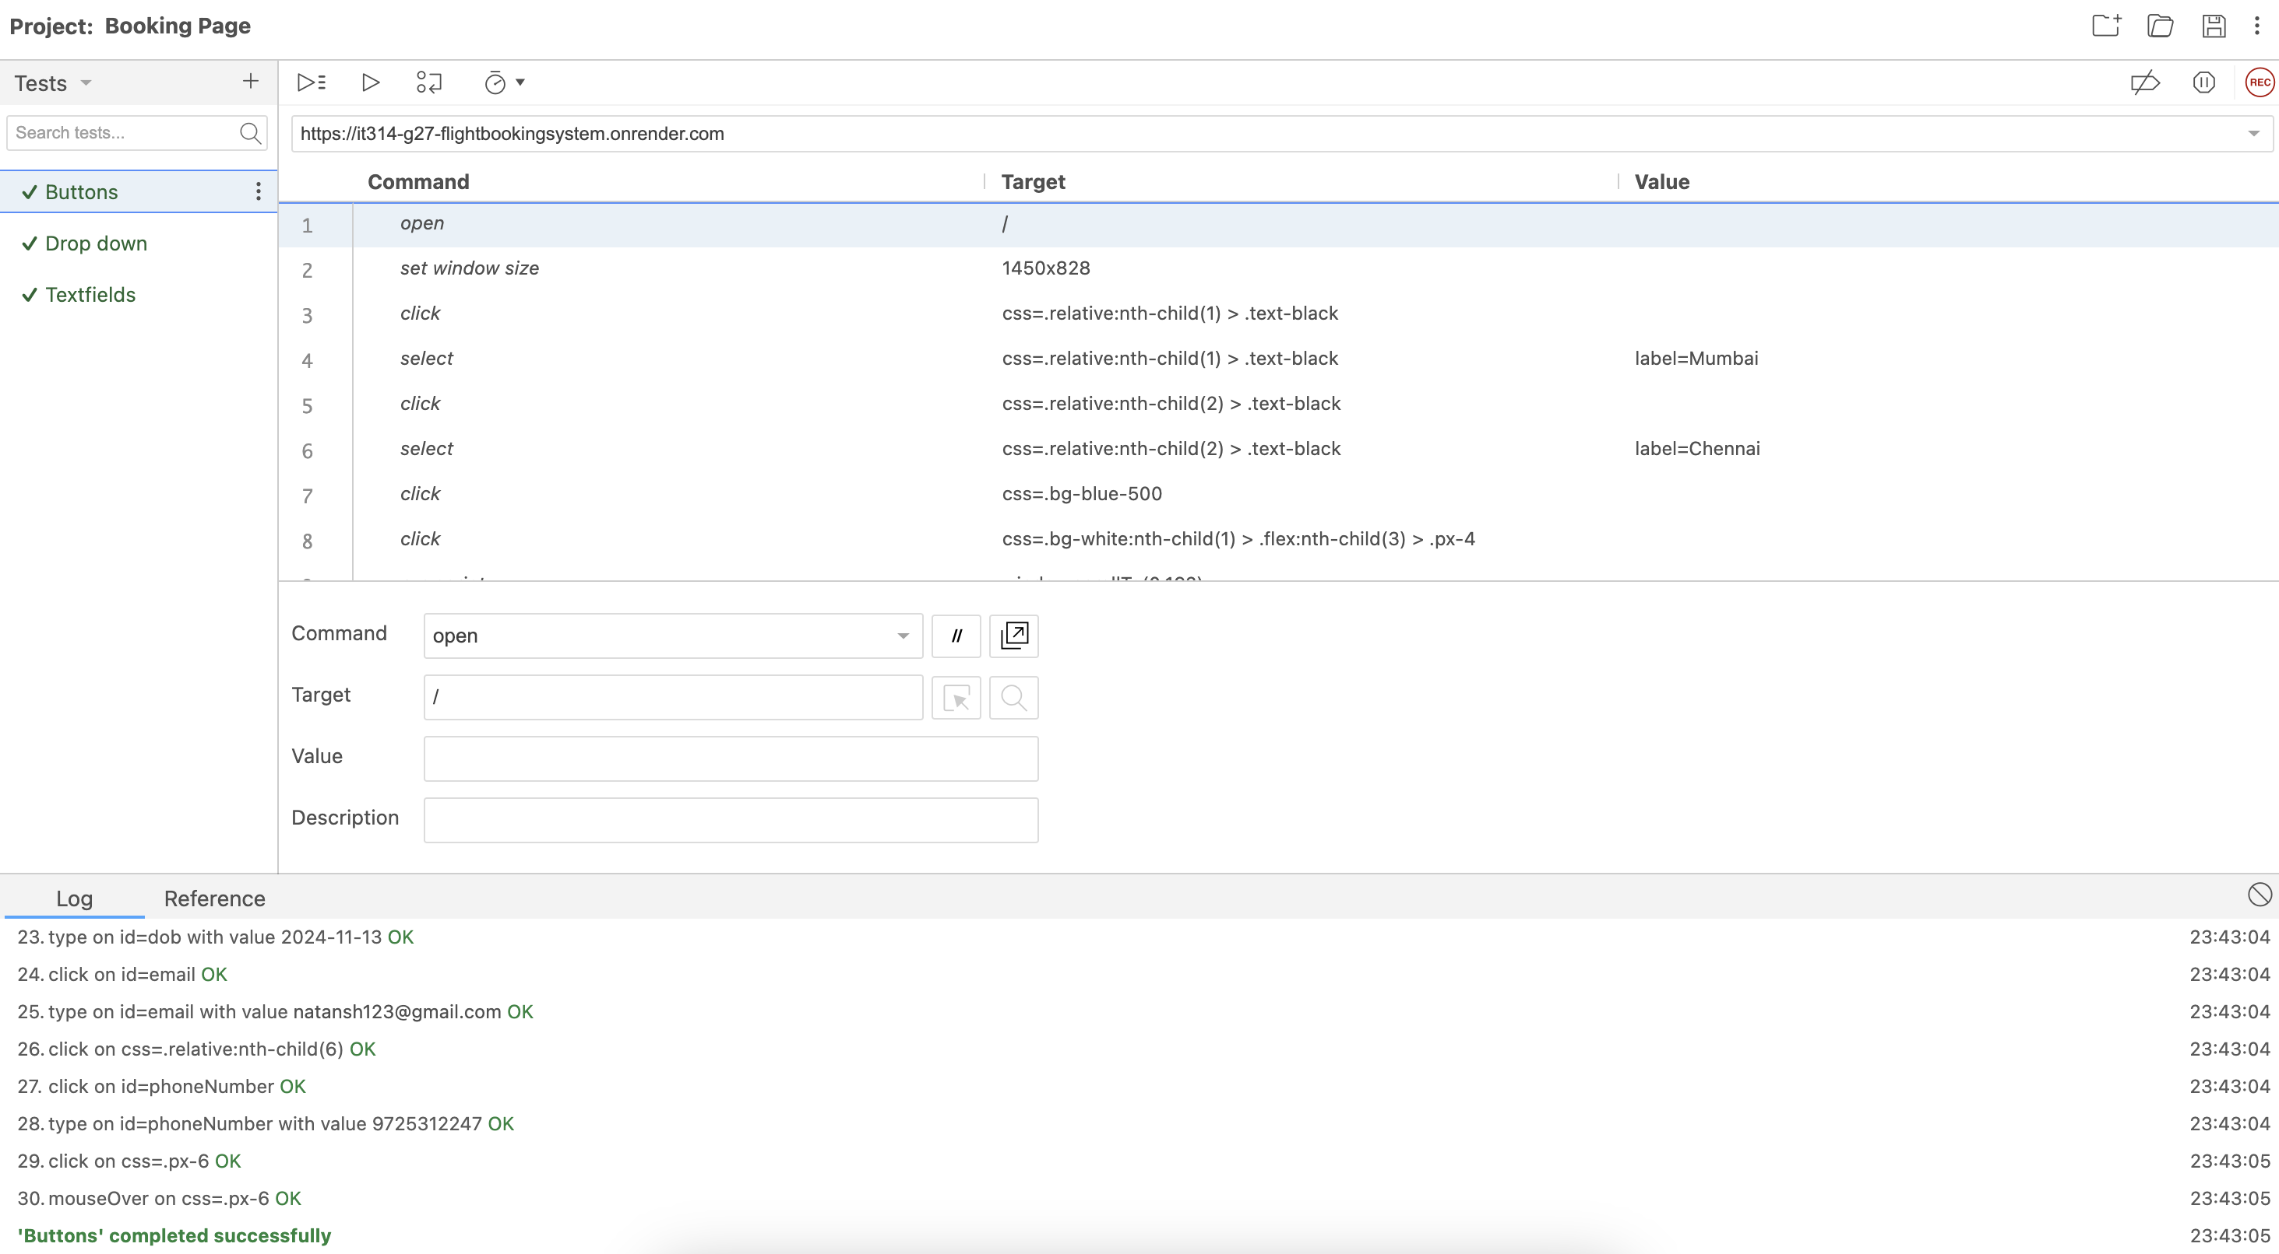

Dropdown :

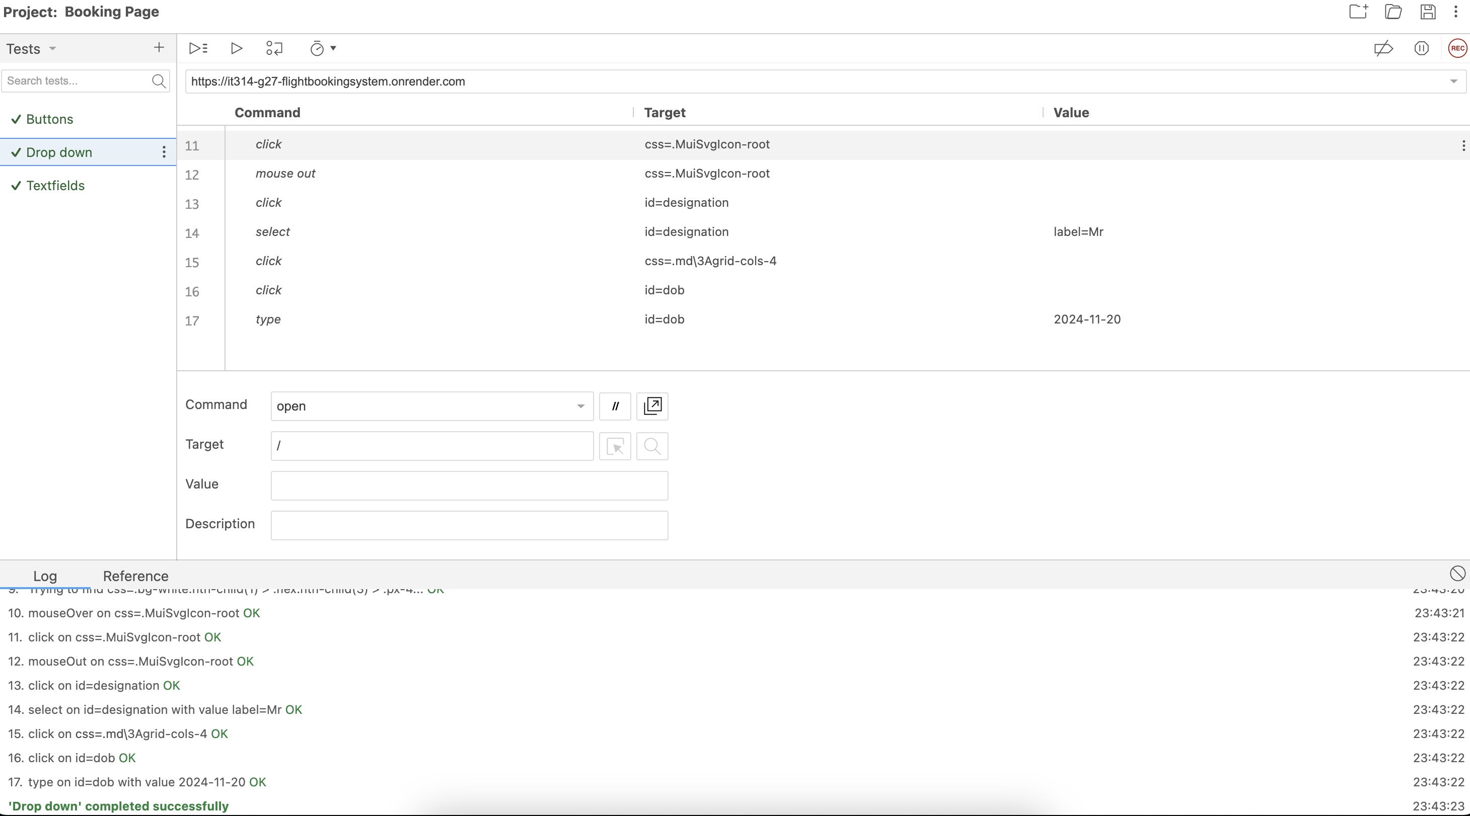

Textfields :

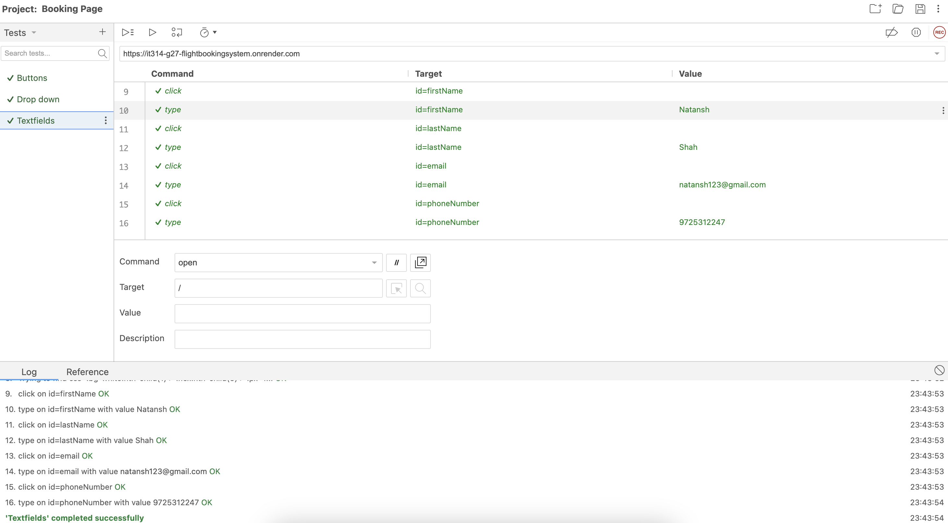

# About Us- Our Team:

|  |  |  |
| --- | --- | --- |
| **Functionality** | **Comments** | **Error to be solved** |
| Text | Done, good UI | Change in Heading “Presenting Our team” |
| Text-fields | No text field (not required) | None |
| Dropdown | No drop-down(not required) | None |
| Buttons | Done, Working properly. | None |
| Check Box | No check box | None |
| Radio Button | Not present | None |
| Hyperlink | All routes and redirections working properly. | None |
| Image | Good selection of images which signifies the role | None |
| Other | Good UI overall | None |

**Selenium Test Case:**

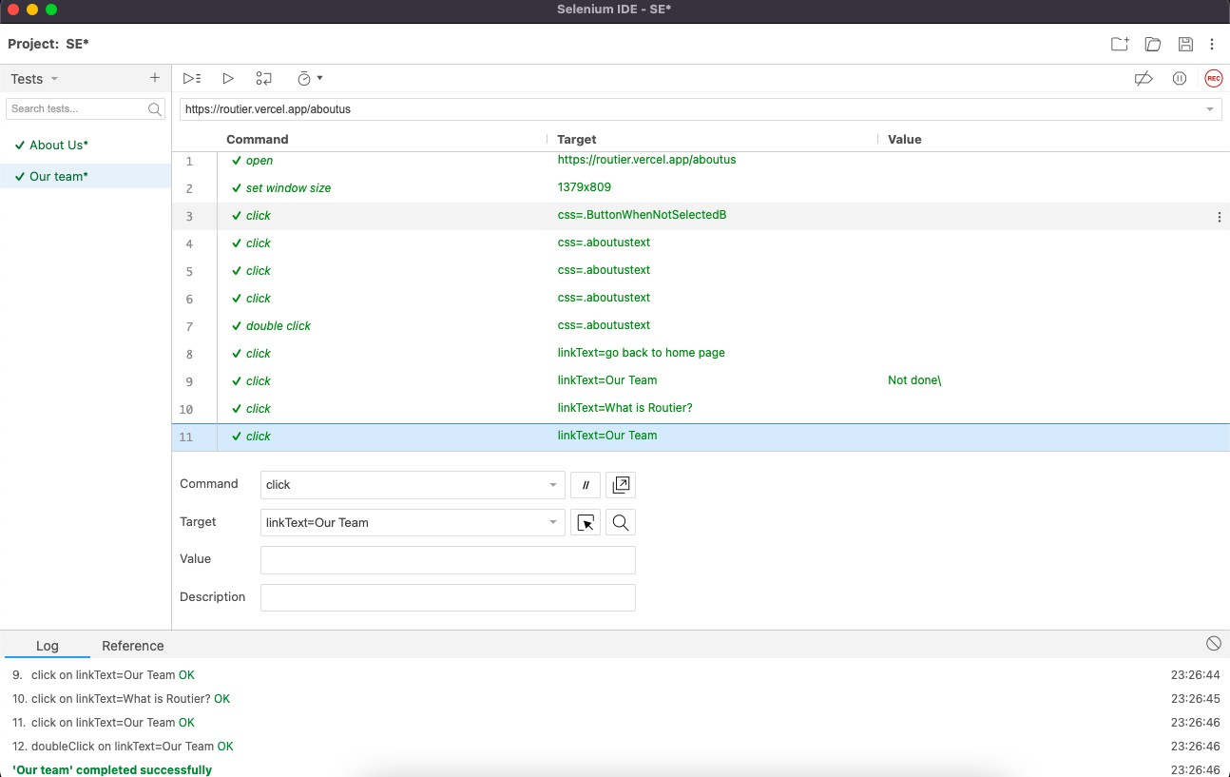

# Add Ons Page:

|  |  |  |
| --- | --- | --- |
| **Functionality** | **Comments** | **Errors to be**  **resolved** |
| Text | Done, good UI | None |
| Text-fields | No text field (not required) | None |
| Dropdown | Done, All dropdowns working properly. | None |
| Buttons | Done, Good design of the  Buttons. | None |
| Check Box | No Check Box | None |
| Radio Button | Not present | None |
| Hyperlink | All routes and redirections working properly. | None |
| Image | No images used. | None |
| Other | Great UI overall. | None |

## Selenium Test Case:

Buttons:

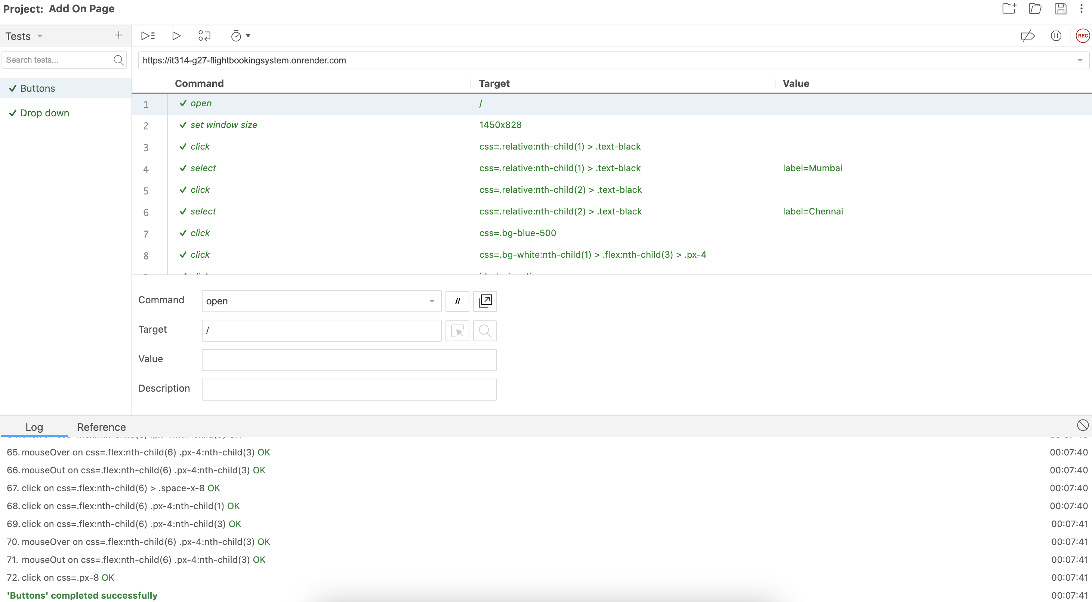

Dropdown :

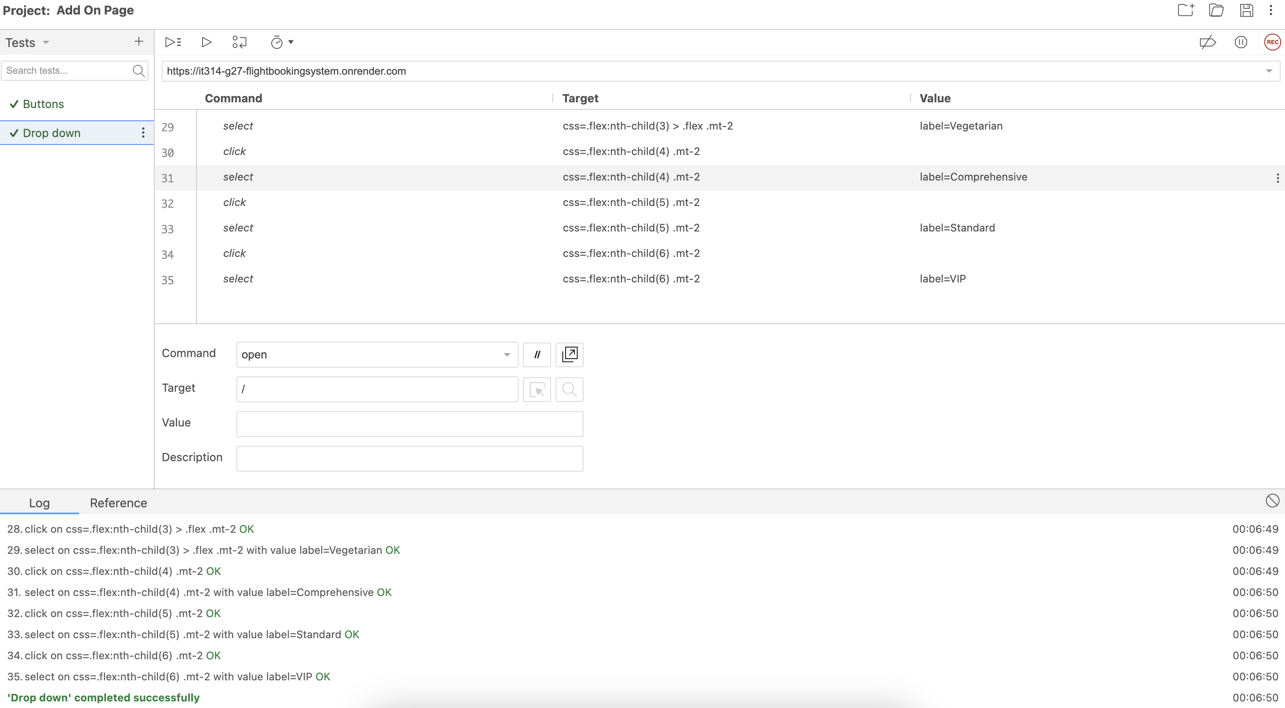

# Payment Page :

|  |  |  |
| --- | --- | --- |
| **Functionality** | **Comments** | **Errors to be**  **resolved** |
| Text | Done, All text aligned | None |
| Text-fields | Done, All text-fields working properly. | None |
| Dropdown | No drop-down (not required) | None |
| Buttons | Done, Good design of the  buttons | None |
| Check Box | No Check Box | None |
| Radio Button | Not present | None |
| Hyperlink | All routes and redirections working properly. | None |
| Image | Not used. | None |
| Other | Done, Payment facilities are sufficient. | None |

## Selenium Test case:

Buttons:

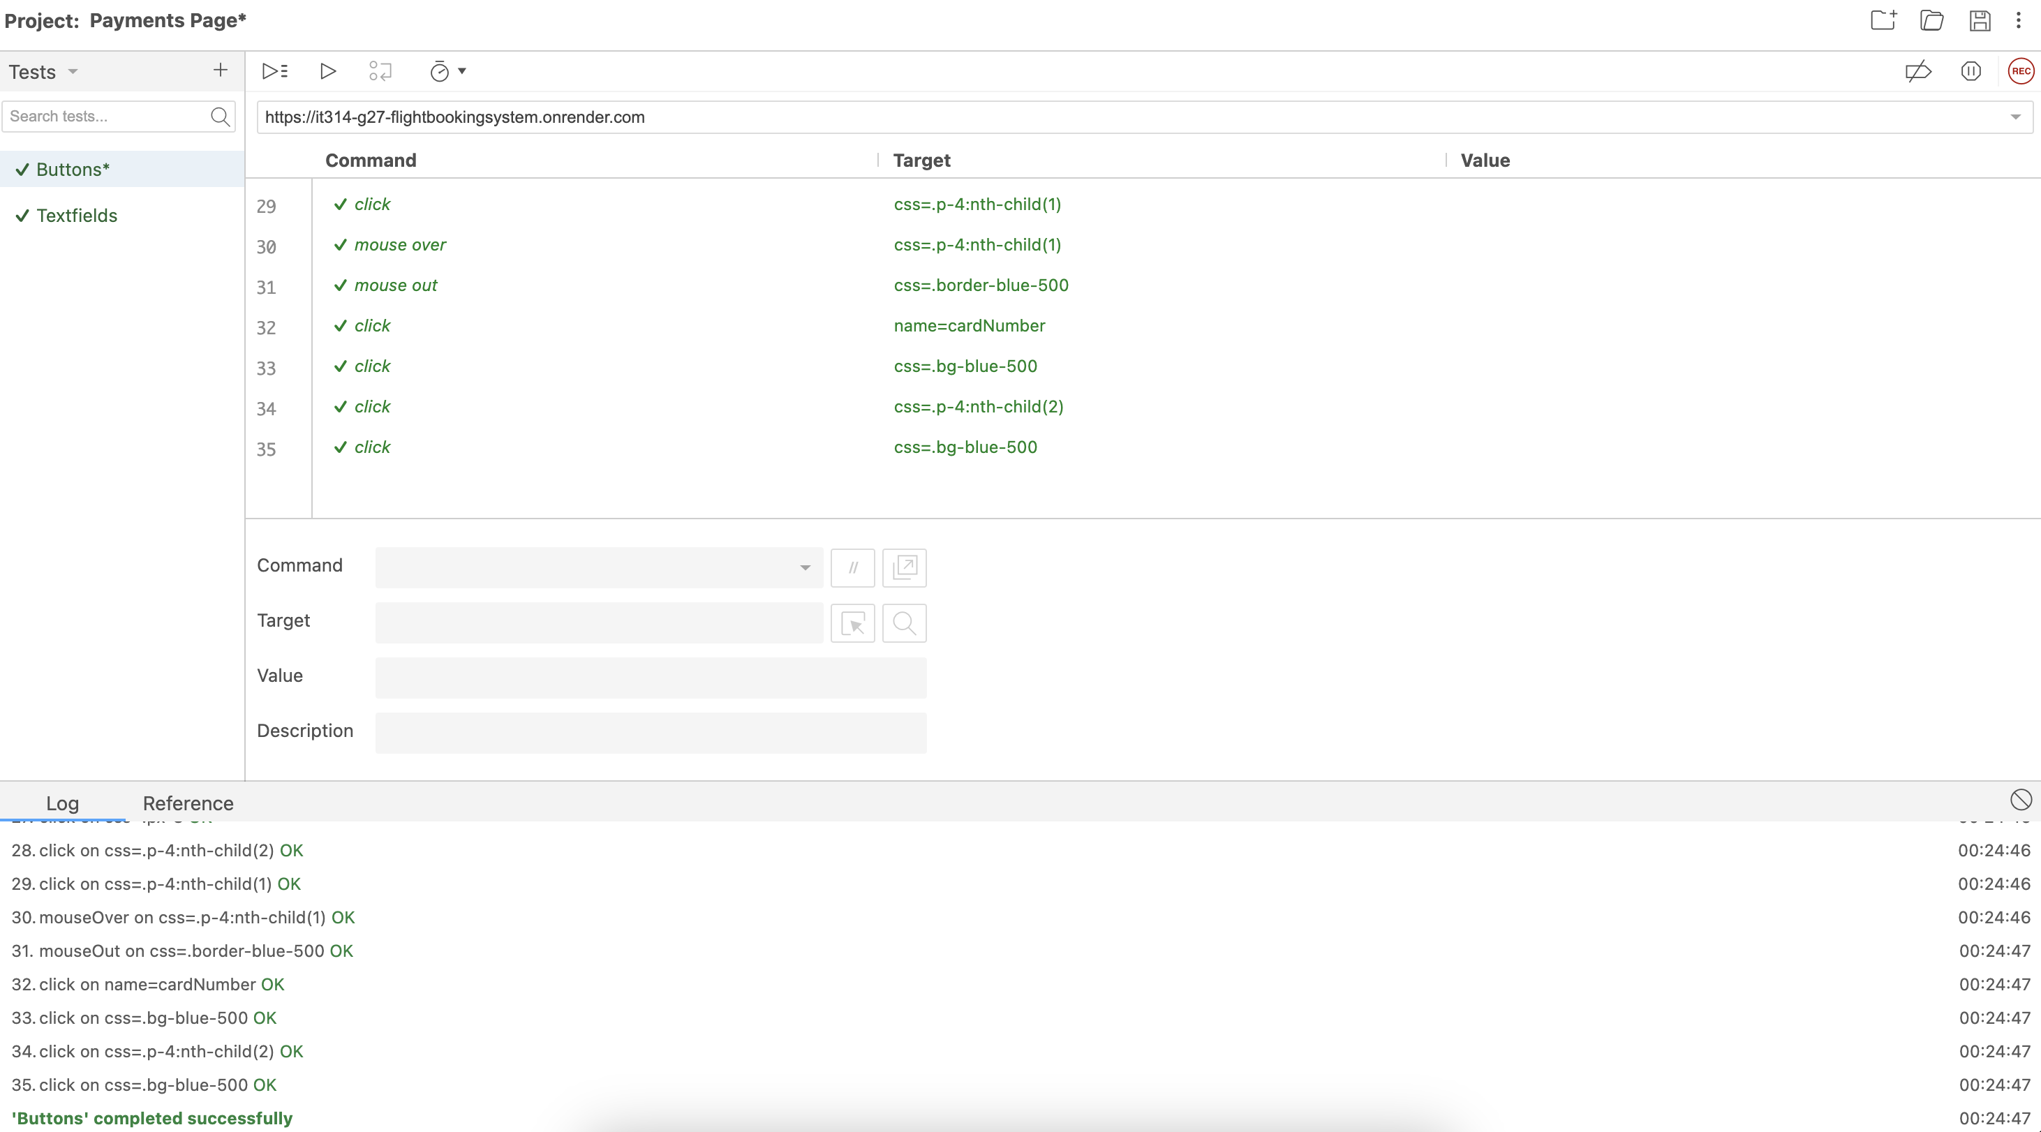

Text fields :

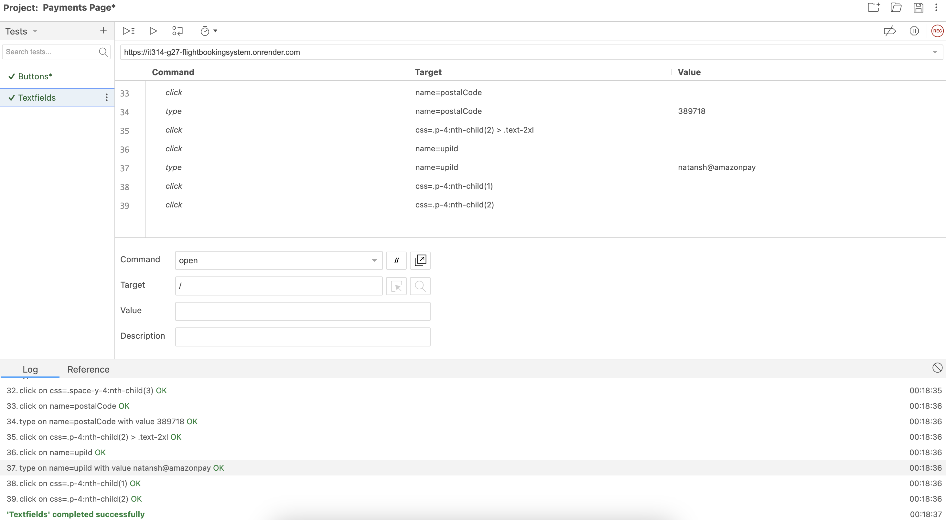

1. **Profile Page :**

|  |  |  |
| --- | --- | --- |
| **Functionality** | **Comments** | **Errors to be**  **resolved** |
| Text | Done, Good UI, Readable | None |
| Text-fields | Done, All text-fields working properly. | None |
| Dropdown | No drop-down (not required) | None |
| Buttons | Done, working perfectly. | Need more contrast |
| Check Box | No Check Box | None |
| Radio Button | Not present | None |
| Hyperlink | Not present. | None |
| Image | No images | None |
| Other | Good UI overall | None |

## Selenium Test case:

Buttons:

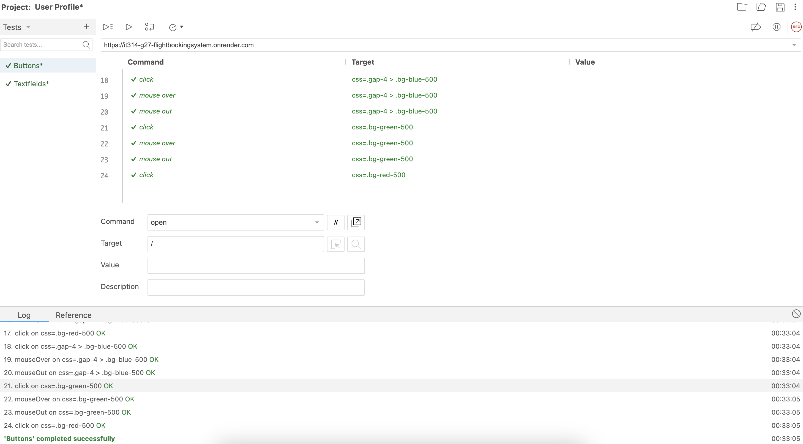

Textfields :

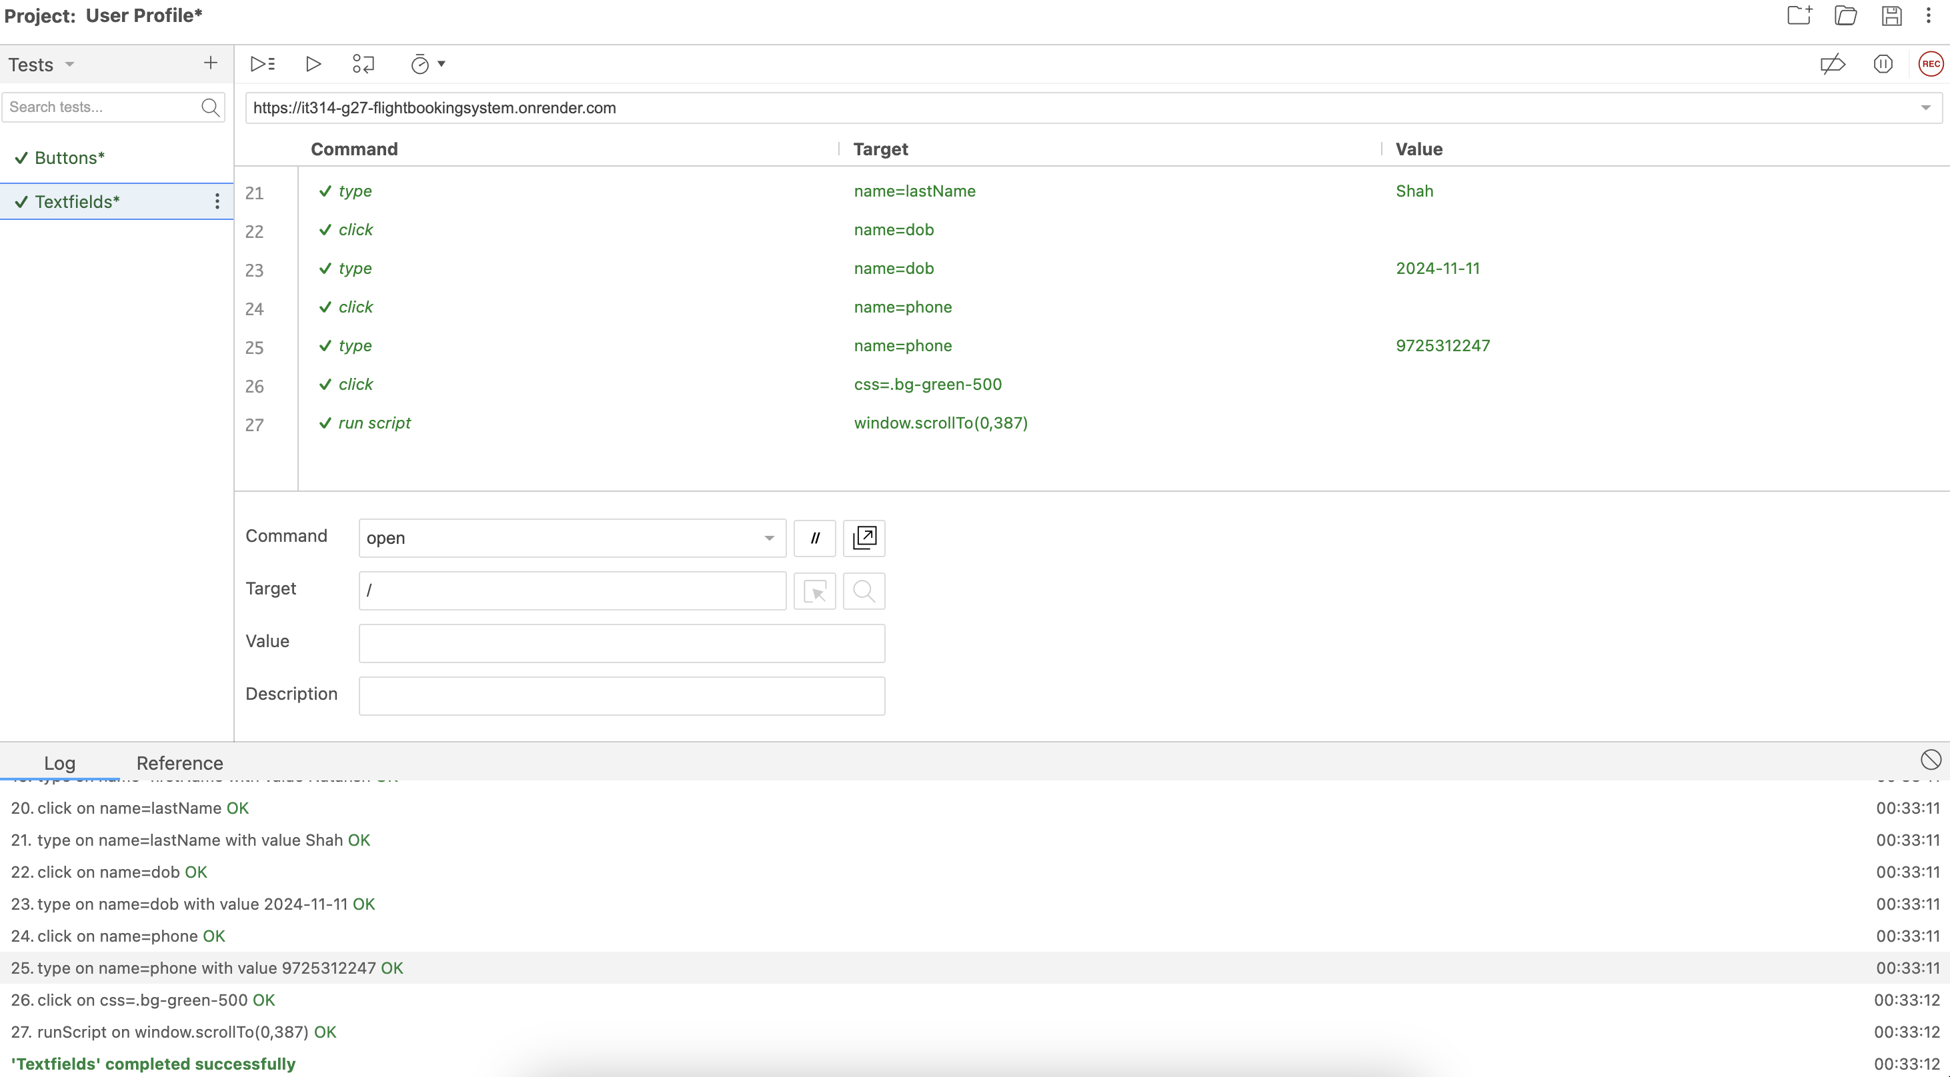

1. **FAQ Page:**

|  |  |  |
| --- | --- | --- |
| **Functionality** | **Comments** | **Errors to be**  **resolved** |
| Text | Done, Good UI, Readable | None |
| Text-fields | No text field (not required) | None |
| Dropdown | Done, dropdowns working perfectly. | None |
| Buttons | Not present | None |
| Check Box | Not present | None |
| Radio Button | Not present | None |
| Hyperlink | Not present | None |
| Image | No images | None |
| Other | Good UI overall | None |

## Selenium Test case:

## 